# Shapiro-Wilk Normality Test in Python

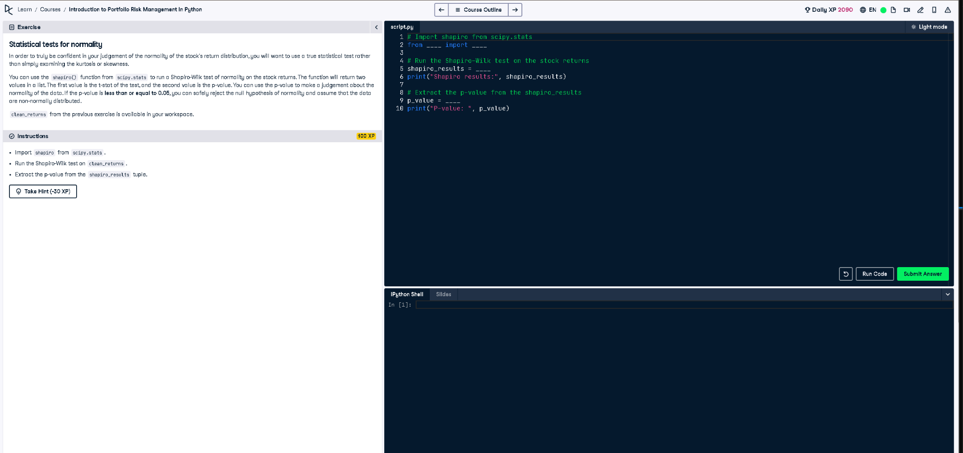

Figure: Screenshot of the coding environment and task.

## Full Python Code

# Import shapiro from scipy.stats  
from scipy.stats import shapiro  
  
# Run the Shapiro-Wilk test on the stock returns  
shapiro_results = shapiro(clean_returns)  
print("Shapiro results:", shapiro_results)  
  
# Extract the p-value from the shapiro_results  
p_value = shapiro_results[1]  
print("P-value: ", p_value)

## Explanation (50 words)

This code tests if the stock returns follow a normal distribution using the Shapiro-Wilk test. The output includes a p-value. If the p-value is 0.05 or less, it suggests the data is not normally distributed. Otherwise, the data can be assumed to follow a normal distribution.